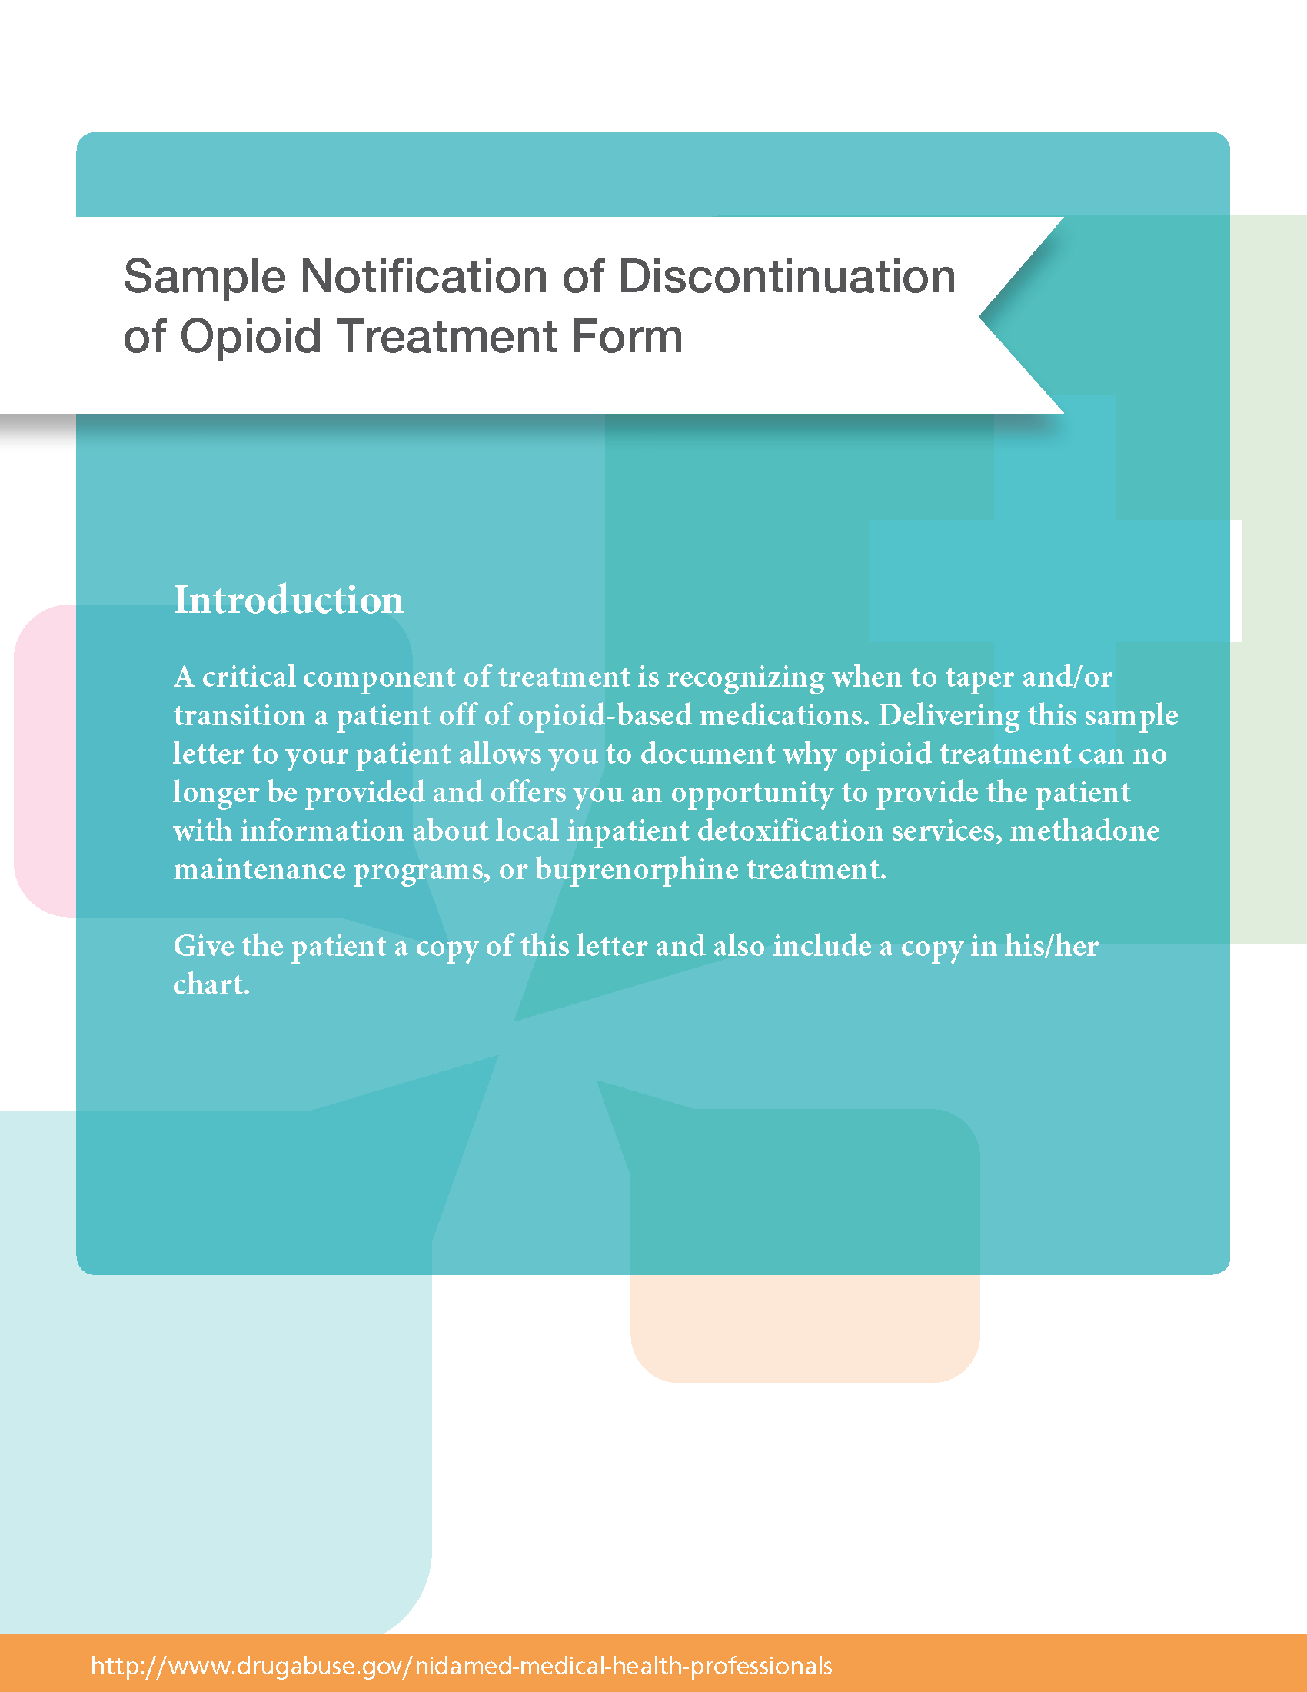

Sample Notification of Discontinuation of Opioid Treatment Form

Dear , Date:
Although you are welcome to continue receiving medical treatment in this office, I regret that I will no longer be able to provide opioid treatment for you due to the following circumstances:
1.
2.
3.
Because opioids cause physical dependence when taken regularly, you may experience withdrawal symptoms when you decrease or stop taking the medications. If it is safe to do so, I will provide you with medications for a period of weeks to allow you to taper off of these medications. I will also provide non-opioid medications to minimize withdrawal symptoms. Please follow the directions provided to taper off the medications.

To locate addiction treatment services in [Insert State], call [insert phone #].

In [insert region of State], for inpatient detoxification services please call:
- [insert service organization and city] | [insert phone #]
- [insert service organization and city] | [insert phone #]
- [insert service organization and city] | [insert phone #]

For methadone maintenance or buprenorphine treatment, please call:
- [insert methadone maintenance or buprenorphine treatment facility and city] | [insert phone #]
- [insert methadone maintenance or buprenorphine treatment facility and city] | [insert phone #]
- [insert methadone maintenance or buprenorphine treatment facility and city] | [insert phone #]

Sincerely,

